Project3
Senior Healthcare Accessibility Analysis in San Francisco

Yan Zhang & Haoxing Deng
Professor Siqin (Sisi)Wang
SSCI 583 Spatial Analysis and Modeling
March 13th, 2025

Individual Contribution:
Preparation and software operation:
Yan Zhang:
Workflow making, service area analysis, OD matrix analysis, figures making
Haoxing Deng:
Data source searching, workflow revising, 2SFCA analysis

Completion of the report:
Yan Zhang:
Methods, Discussion, Reference list, report layout setting
Haoxing Deng:
Introduction, Study area, Data table, Results

1.Instruction
Spatial accessibility refers to the ease with which individuals can access services or facilities according to their geographic location. This concept encompasses various factors, including the distance individuals must travel, the availability of transportation options, and the distribution of services within a defined area. In Project 3, our objective is to evaluate elderly residents' accessibility to senior clinics and general hospitals. We employ the Two-step Floating Catchment Area (2SFCA) method as discussed in Lecture 3 and applied using ArcGIS Pro.
In the first step, we analyzed the accessibility of facilities in relation to the elderly population they serve. In the second step, we assess the accessibility for elderly residents by considering the ratio of the number of residents in each area to the available healthcare services. This analysis enables us to identify the overall accessibility and coverage of these essential services for the elderly population.

2. Study Area
Our study focuses on the area of San Francisco, specifically targeting elderly residents. We selected data for individuals aged 65 and older from the U.S. Census. Figure 1 displays the spatial distribution of healthcare facilities in San Francisco, specifically focused on services for the elderly. Various shades of brown represent the concentration of senior residents across different block groups, with darker areas indicating higher population of elderly individuals. The green circles on the map pinpoint the locations of healthcare facilities that cater to seniors. Notably, these facilities appear to be clustered primarily in the northern part of the city, suggesting potential disparities in access for elderly residents located in the southern regions.
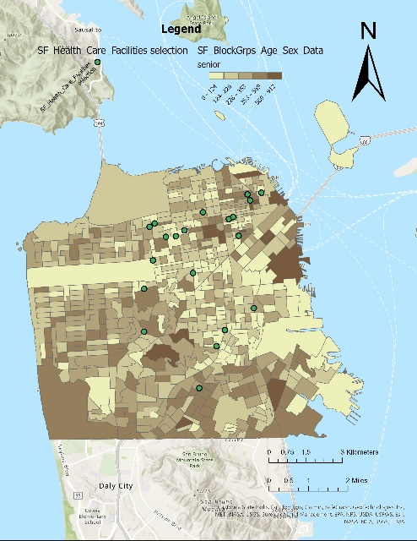
Fig1 Number of elderly persons by district and selected facilities

3. Methodology

3.1 Date preparation

For this project, we are utilizing four datasets. The first two datasets are directly downloaded from Brightspace. The remaining two datasets are derived from the initial two, specifically selected to enhance our analysis.

Table 1 Data Table
Dataset | Format | Source | Description
SF_Health_Care_Facili  ties_healthcare | Vector Point  Data | Data SF | San Francisco  healthcare facilities
SF_BlockGrps_Age_S  ex_Data | Vector Polygon  Data | US Census | San Francisco  Population distribution
SF_Health_Care_Facili  ties_healthcare_senior | Vector Point  Data | Selected from SF_Health_Care_Facili  ties_healthcare | Locations of healthcare  facilities for senior  people
SF_BlockGrps_Age_S  ex_Data_senior | Vector Polygon  Data | Selected from SF_BlockGrps_Age_Sex_Data | Population distribution over 65 years old

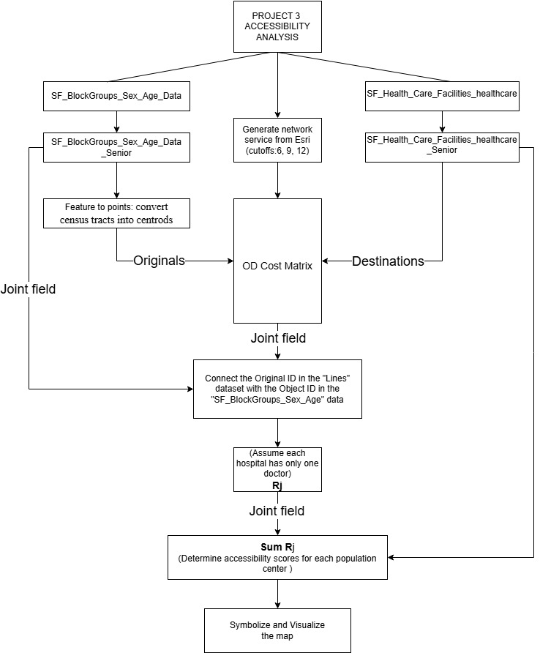
3.2 Workflow

Figure2 workflow

3.3 Two-step Floating Catchment Area (2SFCA)
We firstly downloaded the network service area using data from Esri official website. Considering that the limited mobility of older people, the mode of transportation we choose is driving. Shi, Wang, Zhou, and Zhang (2024) assess the accessibility of emergency rescue services in the context of urban waterlogging disasters. The ideal response time for emergency rescue services is 6 min, while internationally, the general time regulation for emergency rescue is set between 8 to 10 min. According to the relevant regulations in Guangzhou City, the maximum time for emergency rescue services to reach the demand location from departure should be 12 min. So, they argue that cutoffs of 6, 9, and 12 minutes are reasonable thresholds, a perspective we also adopt in our analysis. Imported the facilities as described below and generated the covered area map by different time radiuses. Plus, using variable catchment sizes like this can compensate the MAUP issue to some extent.

To generalize the distance between the facilities and dwelling places, we created the OD Cost Matrix utilizing the "Feature to Point" tool to convert census tracts (representing seniors aged 65 and older) into centroids, which we then used as origins. The destinations selected for our analysis are the locations of healthcare facilities specifically catering to seniors, and to make them more inclusive, we exclude the service like mental and general health, only remain the more comprehensive senior health and hospital.

In the first step of the 2SFCA analysis, we need to connect the Original ID in the "Lines" dataset with the Object ID in the "SF_BlockGroups_Sex_Age" dataset using a joint field to obtain the summarized population of seniors. Since specific data on the number of doctors working with seniors at each hospital is unavailable, we will assume that each hospital has same number doctors, which we set to one. This allows us to create a new column, Rj, in the final layer, calculated as the number of doctors at each hospital for seniors divided by the summarized population of senior individuals.

To score the availability of healthcare resources for seniors of each specific area, in the second step of the 2SFCA analysis, we use the joint field once more to associate the Rj values with their corresponding locations. By summing up the Rj values for each census block group within a predefined travel range using the summarize tool in the attribute table, we calculate the total accessibility score (sum Rj) for each block group.

4.Results
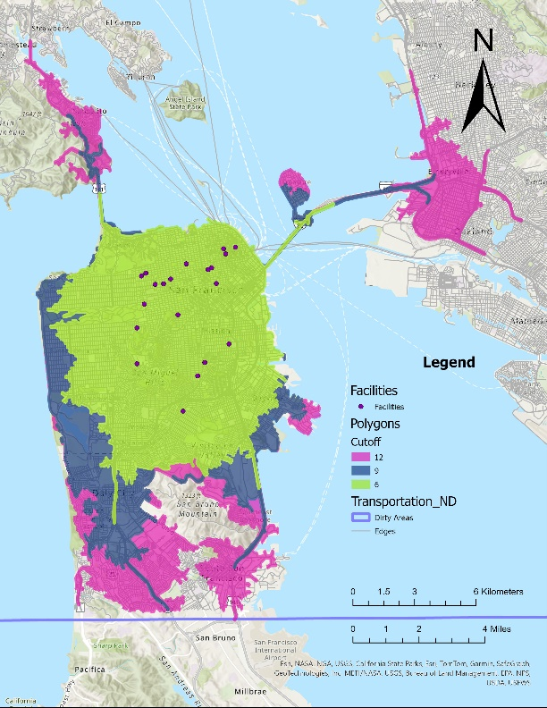
In the analysis of the service area, we found that a drive of about 10 minutes basically covers the entire city of San Francisco, as well as parts of neighboring cities such as South San Francisco, Oakland, Daly city, Sausalito, without considering the distribution of medical facilities there. So, it basically meets the requirements for emergency assistance without traffic jams.
Fig3 Service Area Analysis
In the result of origin-destination cost analysis, the blue dots are the shaped centers of each neighborhood, and the yellow squares are the selected medical facilities. When filtering out routes with linear lengths greater than 10 km or more, we find that the number and density of total routes are not significantly reduced, indicating that the current healthcare facilities in San Francisco City can basically meet the needs of the elderly population.

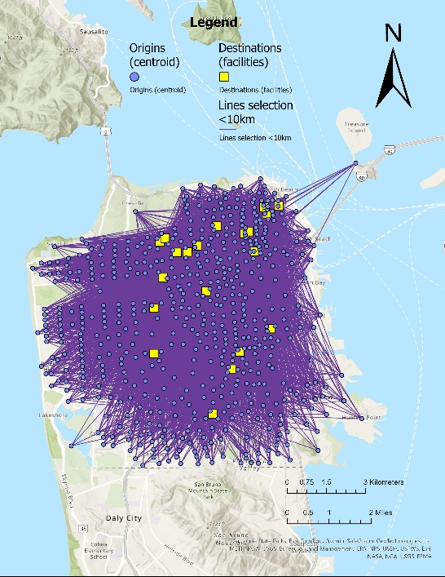
Fig4 OD （Origin-Destination）Cost Matrix
In the supply-demand ratio analysis, due to missing data on the elderly population in some neighborhoods, they are shown in transparent colors in the results map. Areas in the southeast near the port have more healthcare resources per capita and darker neighborhoods due to a smaller elderly population and proximity to several medical facilities. As can be seen in Figure 1, the south has larger elderly population but is less accessible as it is further away from the city center, which is rich in medical resources. A similar problem exists in the western part of the city.
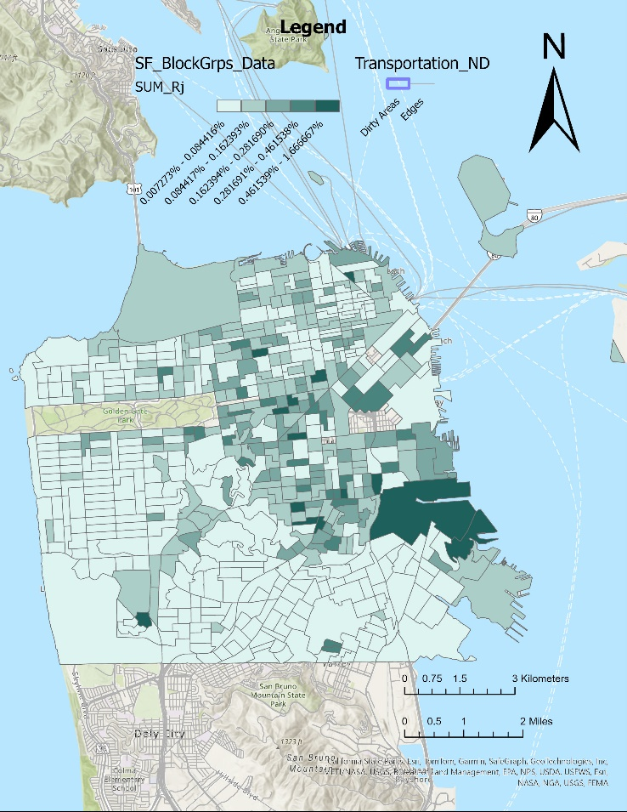
Fig5 Result of 2SFCAM

5.Discussion
In reality, using our analysis as a reference, if the government wants to make the availability of healthcare resources more equitable, new elderly health facilities should be located in the western and southern parts of the city.
Considering the Modifiable Areal Unit Problem (MAUP), we thought that the way spatial units (e.g., census tracts, ZIP codes) are defined can influence accessibility scores because it varies from size. If administrative boundaries do not align with true healthcare service areas, the estimated accessibility can be misleading. And different levels of spatial aggregation (e.g., using large regions versus small neighborhoods) can produce different results. A larger unit might average out disparities in access, while smaller units may exaggerate localized variations.
In terms of edge effects, populations at the boundaries of neighborhoods may actually be more or less likely to have access to healthcare resources, compared to the average for the area, which can significantly impact healthcare accessibility estimates because we used centroids to represent the entire area.
To mitigate the edge effects, a gravity-based accessibility measure in the spatial interaction (SI) models (Haynes & Fotheringham, 1984) is introduced to remedy the issue of obfuscating statistical metrics, Chen (2017) has proposed to consolidate food supply, demand, modalities, and travel time in a holistic approach.
Using the shortest distance along the route combined with the real road network instead of choosing the Euclidean distance for the catchment radius and introducing a probability function of the elderly population’s choice considering the influence of institutional capacity and service quality are also available ways to improve calculation accuracy and improve the mathematical model based on the two-step floating catchment area method (2SFCA) (Liu et al.,2022).
The results of our analysis must have a large deviation from the real situation, in order to make the results of the analysis more accurate, we need more accurate data, such as the number of doctors in each hospital, real-time road conditions, such as the closure of the road, the peak and the average speed of the traffic during the peak period, and the distribution of health care facilities in the surrounding cities, the dynamic health care resources during the period of influenza and so on.
In the Two-Step Floating Catchment Area (2SFCA) method, in addition to the above issues, there are also the problems of a single mode of transportation, which does not take into account the distance and time needed to get from the residence to the car and from the parking lot to the clinic, the actual situation and financial condition of the patient, and the professional and service capacity of the hospital.

Reference
Chen, Xiang. (2017). Take the edge off: A hybrid geographic food access measure. Applied Geography. 87. 149-159. 10.1016/j.apgeog.2017.07.013. https://doi.org/10.1016/j.apgeog.2017.07.013
Shi, Jiafu, Hao Wang, Jinjun Zhou, and Shuxun Zhang. 2024. "Assessment and Improvement of Emergency Rescue Service Accessibility under Urban Waterlogging Disasters" Water 16, no. 5: 693. https://doi.org/10.3390/w16050693
Liu, Linggui, Han Lyu, Yi Zhao, and Dian Zhou. “An Improved Two-Step Floating Catchment Area (2SFCA) Method for Measuring Spatial Accessibility to Elderly Care Facilities in Xi’an, China.” International Journal of Environmental Research and Public Health 19, no. 18 (2022): 11465-. https://doi.org/10.3390/ijerph191811465

